

Project brief

Status In progress
Timing Jan 23, 2026 to Jan 26, 2026
Owners Salman Birajdar

Overview

Acme Dental is a simple dental practice that offers routine check-up appointments. The clinic operates with a single dentist and uses Calendly to manage its appointment scheduling. Below are the key details you'll need to know about the clinic's operations.

Clinic Information:
Service Type: Dental Check-up (only service offered)
Appointment Duration: 30 minutes
Staff: Only 1 dentist
Scheduling System: Calendly
- Calendar URL: Provided in the email.
- Calendly Token: Provided in the email.
- Use the Calendly API to check availability and manage bookings

Objectives
Build an AI agent that allow users to book dental check-up appointments with a fictitious Acme Dental clinic through natural language conversation in a chat interface.

Project objectives
Functional Requirements
- Create New Bookings
- Greet users and understand their booking intent
- Check available appointment slots via the Calendly calendar
- Present available time slots to users
- Help users select a suitable time slot
- Collect necessary patient information (i.e full name and email address)
- Create the booking through the Calendly API
- Provide confirmation with appointment details (date, time, duration)
- Reschedule Existing Bookings
- Allow users to reschedule their existing appointments
- Identify the booking to update
- Retrieve current appointment details
- Check availability for the new requested time slot
- Reschedule the booking through the Calendly API
- Provide updated confirmation with new appointment details
- Cancel Bookings
- Allow users to cancel their appointments
- Identify the booking to cancel
- Retrieve current appointment details
- Process cancellation through the Calendly API
- Provide cancellation confirmation
- Answer FAQs from the Knowledge Base
- A document containing the clinic's knowledge base (KB) will be provided
- Extract and process information from the document to build a searchable knowledge base
- Answer frequently asked questions about the clinic using information from the KB
Non-Functional Requirements
- Implement the agent using LangGraph (https://docs.langchain.com/oss/python/langgraph/overview)
- You are free to choose the LLM model(s) or a combination of models you consider most appropriate for this task
- Be aware that API integrations (e.g., Calendly) may be unreliable or experience delays
- Document your architectural decisions

Strategy

Target audience
- Users are trying to book an appointment for Acme Dental
- Doctor using the Calendly app to view the bookings

Measurement
Success Metrics:
- All the functional requirements above are met
- CSAT > 95 % (This is the customer satisfaction metric)
- Task completion rate ~ 100 %
- Intent recognition rate (How accurately the model understands the customer intention)
- Conversation efficiency (Time taken from conversation start to completion of a task)
- Latency Target: < 1.5sec (Time taken by agent to give a response)
- Reliability ~ 100%

File File

Edge Cases:

Edge Case | Risk | Mitigation
Same user books multiple times | Double appointments | Check availability window limits
Race condition - two users book same slot | One fails | Handle 409 conflict, offer next available slot
User abandons mid-conversation | Incomplete data | Don't persist partial bookings, session timeout cleanup
User in different timezone | Books wrong time | Detect timezone from browser, confirm with user

Bottlenecks
- LLM latency (1-3 sec typical)
  - Streaming responses, smaller model for simple queries
- Calendly API latency
  - Aggressive caching (poll status update)

Scalability
- In-memory Cache
  - Possibly move to DB
- Single Destist calendar
- Conversation in memory
  - Possibly move conversation to DB

Design:
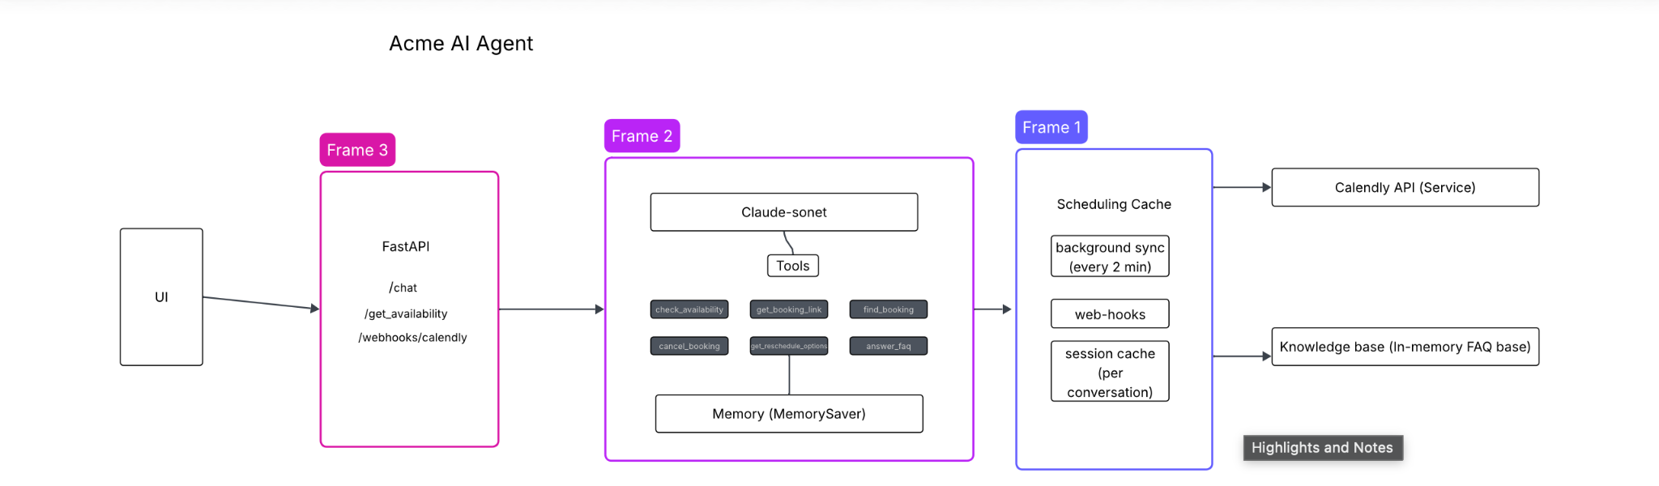

Milestones
Date | Milestone | Description | Expected outcome
Date | Milestone 1 | Add LLM service using Langraph and Claude-sonet | LLM returning responses
Date | Milestone 2 | Integrate an agent with the LLM, along with the tools definition | LLM reasoning well with requests and assigning tools for action
Date | Milestone 3 | Implement scheduling cache and web-hooks for Calendly | In memory cache updated every 2 mins to keep requests in sync with the user
Date | Milestone 4 | Implement FastAPI - Set up endpoints for chat and webhooks | API endpoints returning responses
Date | Milestone 5 | Implement a lightweight UI (Vite -Typescript/React) | UI is able to send requests and receive responses
Date | Milestone 6 | Deploy on Railway | App available on production with a URL to access it

Open questions
- 1. What happens if the Calendly calendar is manually edited? (Webhook handles new bookings, but what about manual time blocks?)
- 2. Should we support multiple languages? (Current implementation is English-only)
- 3. What's the cancellation policy? (How close to appointment time can users cancel?)
- 4. Should we send confirmation emails? (Currently relying on Calendly's built-in emails)
- 5. How long should conversation history persist? (Current: in-memory, lost on restart)
- 6. What's the maximum booking window? (How far in advance can users book?)

Resources
Deployed at: https://acme-dental-front-end-production.up.railway.app/
Repo at: https://github.com/salbirajdar/acme-dental/tree/main
Readme: https://github.com/salbirajdar/acme-dental/blob/main/README.md

